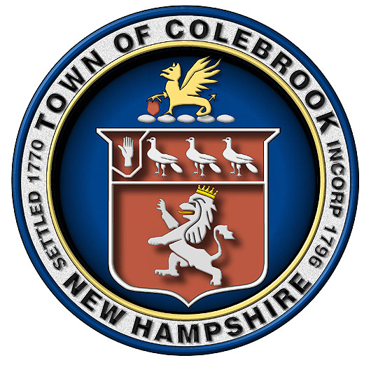
The Town of Colebrook, NH seeks Town Manager
The Town of Colebrook, NH (pop 2,000) seeks a Town Manager to oversee its day-to-day operations including administrative and financial oversight for all departments under the supervision and policy direction of a three-member Board of Selectmen in accordance with NH RSA 37. The Town is nestled in the heart of the Great North Woods on the Connecticut River. With a population of approximately 2,000 people, Colebrook is a great community in which to live, work and play. Tourism is one of Colebrook's largest industries with easy access to numerous recreational opportunities. Colebrook is a multi-service municipality with full-time business office, police, highway, recreation, water and sewer departments.
Candidates must demonstrate leadership along with a proven record of managing people through a collaborative team approach. Outstanding analytical, financial, communication, organizational and planning skills are essential. Candidates should possess a bachelor’s degree and a minimum of five years’ public or private sector management experience. An equivalent combination of education and experience may be considered. The ability to manage a multi-million-dollar budget, oversee long term municipal projects, coordinate the activities of multiple boards, and committees is critical. Grant writing and grant administration experience is a plus. The Town of Colebrook offers a competitive salary and generous benefit package. Residency is not required but preferred.
Interested candidates who have a passion for serving local government and its citizens are invited to submit a detailed letter of intent, résumé, salary requirements and references in confidence to gregplacy@gmail.com Subject: Town of Colebrook, Town Manager Search or by mailing documents to Town of Colebrook, Town Manager Search, 17 Bridge Street, Colebrook, NH 03576, Attention Chairman Greg Placy. Résumés will be accepted and interviews scheduled until the position is filled.
EOE

