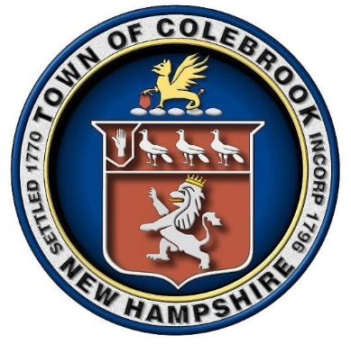
Town of Colebrook
17 Bridge Street
Colebrook, NH 03576
(603) 237-4142
(603) 237-5069 Fax#

Colebrook Selectman’s Meeting Agenda
Monday, March 23, 2026, at 5:00PM
Town Hall Courtroom

ROLL CALL & PLEDGE OF THE ALLEGIANCE

- HEARING OF THE PUBLIC:

  - Public Hearing on ICE 287 (g) funds.
  - Alicia Boire, Town Treasurer
  - Jeff Dobson

- REGULAR AGENDA:

  - Review and approval of Minutes of 3/3/26
  - Review and Sign Payroll and Disbursement Manifests.
  - Town Manager’s Report

- NEW BUSINESS:

  - Ahead Agreement
  - North Country Community Rec Center Agreement Status
  - Election of Officers & Committee Assignments
  - Water Department-Short Lived Assets Account for VFD Fan
  - Water & Sewer Departments-Status of Correcting Styles/Badger Monthly Billing
  - 2.5% COLA Approval
  - Status of White Mountain Communications 2025 & 2026 Rent Due.

- OLD BUSINESS:

  - Reservoir Rd: The Board needs to make a decision.
  - Aldrich Road Update:
  - Water Wells:
  - Follow-Up to Congresswoman Goodlander on North Wells:
  - Status of Tax Deeding:

- TABLED/PENDING ITEMS:

  - Property Tax Abatement: Dagesse Family Trust

- FOR APPROVAL AND SIGNATURE:

  - Veteran’s Tax Credit: Gregory & Linda Lewis
  - Property Tax Abatement: Dennis Bailey $5,300.00
  - Property Tax Abatement: Steve Madonna $95.00
  - Intent to Excavate: Michel Rodrigue/Ronny Rodrique
  - Abatement Requests from DRA:
1.Marc Nugent
2. Ronald & Ronnie Smith
3. Kathleen Reardon & Matthew Bowles
4. Linda & Gregory Lewis
5. Michelle Hyde
6. North Country Community Rec Center

- HEARING OF THE PUBLIC AND ANY OTHER BUSINESS:

- NON-PUBLIC SESSION UNDER RSA: 91-A:3, II (a) and (c):

- DETERMINE DATE FOR NEXT MEETING:

-Selectmen’s Meeting: Monday, April 27th at 5:00pm.

- ADJOURN:

